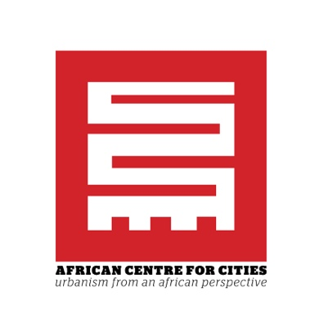

AFRICAN CENTRE FOR CITIES PEAK URBAN POSTDOCTORAL RESEARCH FELLOWSHIP: URBAN GOVERNANCE

The African Centre for Cities (ACC) was established in 2007 at the University of Cape Town as an urban research institute. The ACC is based in the School of Architecture, Planning and Geomatics in the Faculty of Engineering and the Built Environment, but is interdisciplinary in its scope, drawing expertise on urban issues from across the university. The mission of the ACC is to “facilitate critical urban research and policy discourse for the promotion of vibrant, democratic and sustainable urban development across the global South”.

CALL FOR APPLICATIONS
The ACC invites applications for a postdoctoral fellowship to support research associated with the PEAK Urban project (http://peakurban.uk) and complementary work on urban sustainability and governance. The successful candidate will become part of a new global cohort of urban researchers as part of the PEAK Urban project. The ideal candidate will have expertise in urban studies debates, a firm grounding in social science methods, a keen interest in conceptualising and understanding urbanism from a Southern perspective, and a demonstrated ability to engage with comparative and multi-scalar research.

We seek to engage a scholar who will be able to complement and expand ACC’s research thematics in Cape Town and other South African cities, and who will be able to examine and conceptualise the relationship between urban, national and international scales of governance. The successful candidate should also have research interest in understanding how different contemporary political and wider urban governance dynamics in Cape Town relate to each other and to past processes.

To further their professional development, successful candidates will be required to participate in, and support the implementation of, international annual summer schools as part of the PEAK Urban project to occur at one of the PEAK Urban partner sites (South Africa, China, the UK, Columbia or India). The successful candidate will also participate in various other departmental activities

An opportunity to take part in a three-month internship at another PEAK Urban site at some point during the length of the fellowship is also a possibility, dependent on agreement with other PEAK Urban partners and approval by ACC.

CONDITIONS
Applicants are expected to have completed a doctoral degree in an area of study relevant to the post (History, Geography, Sociology, Anthropology, Urban Planning, Development Studies) within the last five years (or be close to completion) and have an academic publication and presentation record commensurate with their stage in academic career.

VALUE AND TENURE
The value of the Fellowship is between R250,000 and R390,000 per year based on experience, and is renewable for a total of up to four years, depending on satisfactory progress. The fellowship does not include relocation costs or fringe benefits. The incumbent will be provided with a desk and appropriate access rights to use the research facilities of the University of Cape Town. The Fellowship will commence 1 April 2018.

APPLICATION REQUIREMENTS
Applications must be submitted by midday on 23rd February 2018 and consist of:
- A letter of application stating areas of expertise, research interests and experience
- Proposed focus of research (maximum of two pages)
- A CV including a list of publications
- Copies of academic transcripts
- The names and contact details of at least two academics who have taught, supervised or worked alongside the applicant as referees

SELECTION PROCESS
Eligible and complete applications will considered by the Director of the African Centre for Cities and a sub-committee
Closing date for applications: Midday on 23rd February 2018

CONTACT DETAILS
Submission
Please submit your application to Maryam Waglay, African Centre for Cities via email to maryam.waglay@uct.ac.za or posting/delivering to Maryam Waglay, African Centre for Cities, Room 2.11, Environmental and Geographical Sciences Building, University of Cape Town, Private Bag X3, Rondebosch, Cape Town, South Africa 7701. Please clearly state that this is an application for the “ACC PEAK Urban Postdoctoral Fellowship on Governance”.
Enquiries
For enquiries regarding the position please contact A/Prof Andrew Tucker at andrew.tucker@uct.ac.za

