Guidelines for Completing an NRF/TWAS Application
Postdoctoral Funding

8/6/2014
University of the Witwatersrand
Robin Drennan

Contents
1 Purpose of this document 3
2 Opening an application form 3
3 Meaning of special icons 4
4 Important recommendations 4
5 What the application form looks like 5
6 Items requiring special attention 6
6.1 Fellowship to be funded 6
6.2 Research Project Information 6
6.3 Details of Research 7
6.4 References 7
6.5 Reviewers 7
7 Final submission 8
8 Conclusion and contact details for further help 8

1 Purpose of this document
This set of guidelines is meant to help you complete a funding proposal using the NRF online application system. The objective is that the online system should not stand in the way of you writing a winning proposal.

Please give us feedback on whether the guidelines assisted in the process and where we can improve them. Send you comments to Ms Mpho Maithufi (Mpho.Maithfufi@wits.ac.za) or Dr Robin Drennan (Robin.Drennan@wits.ac.za).

2 Opening an application form

Follow this link to the application for system: https://nrfsubmission.nrf.ac.za
If you are a first time user of the system please follow these steps to register.
- Click on New Registration – see top left hand side of page and use your SA ID number or passport number to register on the site. Please remember your password!

- Once logged in the page will look like this ...
Again look at the top left hand side and click on My Applications to either
  - Create a new application (choose appropriate one from list), or
  - Open an existing application

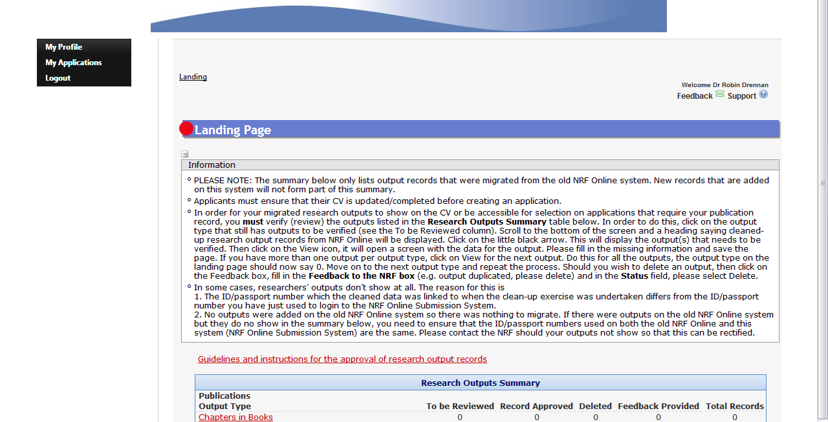

Well done - you now have a blank application for in front of you.

3 Meaning of special icons

The following icons are used throughout the application

- Complete
- Incomplete
- For information only
- Edit
- Delete
* - Compulsory section

4 Important recommendations

Write your application in Word (or similar) format and then copy and paste the writing into the database, but:
- Beware of space the limitations!
- Never use any formatting!
- Always ‘hit’ Save as you go along!

5 Description of the application form
The application for consists of the sections listed below. It looks long but more than half of the sections include your online CV.
Type | Section | My description to aid you in the process of completing
For your information | NRF Call Information Documents (Please read before starting this application) | Documents describing the call and the selection criteria. Read them carefully
CV Section | Registration Details * | This is the information you completed when registering
 | Contact Details * | Make sure your contact details are correct so they can send you your award letter (hopefully)
 | Qualifications * | Add all your qualification in chronological order
 | Research Expertise * | Select and enter a brief description of your research area. The system is hierarchical
 | Personal Profile * | Focus on your research and academic experience demonstrating how it will help you achieve the work proposed in the application
 | Career Profile | Indicate all jobs you have held that help show your academic achievement
 | Books | Enter if available
 | Chapters in Books | Enter if available
 | Refereed/Peer-reviewed Conference Outputs | These are full length peer reviewed papers published in the conference proceedings
 | Articles in Refereed/Peer-reviewed Journals | Important
 | Patents | Enter if available
 | Keynote/Plenary Addresses | Enter if available
 | Articles in Non-refereed/Non-peer Reviewed Journals | Enter if available
 | Other Significant Conference Outputs | Enter if available
 | Technical/Policy Reports | Enter if available
 | Products | Enter if available – have you made something?
 | Artefacts | Enter if available – have you found something?
 | Prototypes | Enter if available – have you tested something?
 | Other Recognised Research Outputs | Enter if available
 | Disability * | Yes or No
 | Degree to be Funded * | The NRF regards a postdoc as a degree. Although this is wrong just choose postdoc.
 | Research Project Information * | This is the project title and 2000 character abstract – first impressions count so do it well – see below for more assistance
Heart of application | Academic Achievements * | Assuming you did not get a mark (grade point) for your PhD, just add the word ‘Pass’ to both boxes and the year in which you completed your PhD in the third box.
 | Details of Research * | This is the essence is the heart of the proposal and consists of four sections – see below for more assistance
 | Science Communication | Explain if you have done any science communication work before. That is you have spoken to the lay public or school children about your research. In the second box indicate your willingness to do scientific communication. I would encourage you to offer to speak to undergraduate students about your research (or something similar).
 | Attachments * | Up load documents that support your application – see check list below
 | References * | Provide contact details for 2 references (referees) namely your PhD supervisor and your host of the postdoc – see below for more details
 | Possible Reviewers | Provide at least 6 possible reviewers – see below for more assistance
 | Declaration * | Check all boxes
 | Checklist * | See below for more information
FYI | Print Preview | When done print a hard copy of the application. Check that is looks neat! Keep a copy for your records
Final Submit

The Final Submit button only becomes active (blue) when all the compulsory sections are marked complete. When you hit this button the application will disappear off your system and will be sent to the Wits Research Office. You may ask us to reopen your application for further editing.

NB! It will only go to the NRF when the Wits Research Office sends it there.

6 Items requiring special attention

6.1 Research Project Information

Here is a screen shot. This section is vitally important! Mainly because first impressions count a lot.
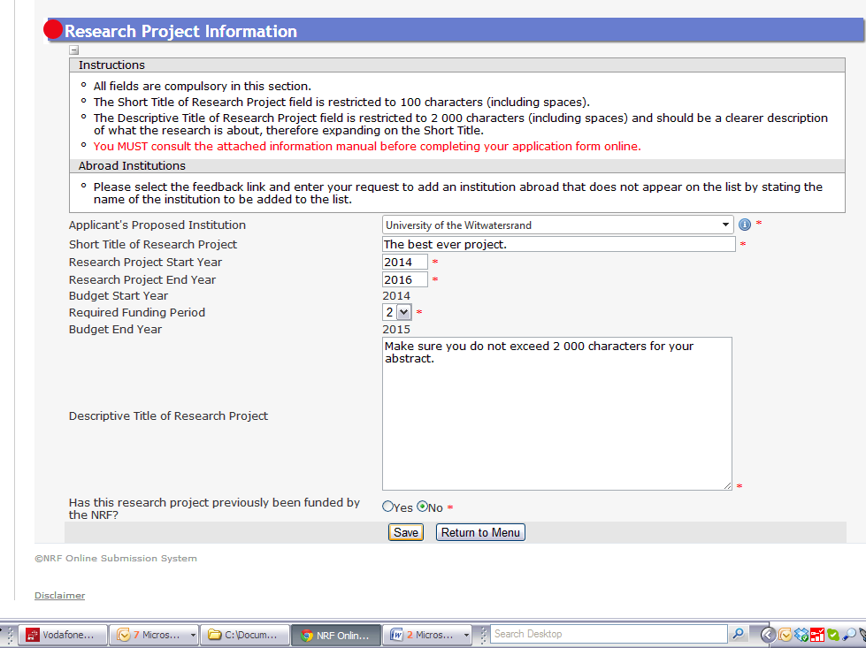

The project title is limited to 100 characters.
The project description – or abstract is limited to 2 000 characters. Make sure you summarise the whole project and make it interesting!

6.2 Details of Research
This is the heart of your application. This is where the research is described.

It consists of four sections:
- Rationale and motivation – Answer three questions in this section: What is known? What is not known? And why is it important to know this? Remember to quote the literature and attach your bibliography.
You are allowed 5 500 characters, which is about three quarters of an A4 page.
- Problem identification – What is your research question(s) or what is your hypothesis?
You are allowed 5 500 characters, which is about three quarters of an A4 page.
- Research aims and objectives – Choose one strategic aim and between 3 and 5 operational objectives.
You are allowed 5 500 characters, which is about three quarters of an A4 page.
- Research activities – This is a work plan, a description of
  - What you will do
  - When you plan to do it
  - With what resources you will require, and
  - The methodologies to be used
You are allowed 5 500 characters, which is about three quarters of an A4 page.

NB! It is a good idea to attach a Gantt chart to help explain your work plan.

6.3 References
Provide the contact details for your:
- PhD supervisor
- New host for your proposed postdoc

Important: Warn these people that the NRF will contact them. Ask them to respond on time and completely to the NRF’s questions.

Important: Make sure you provide up-to-date contact details. If they cannot make contact or get a response from these people you will not get a fellowship award.

6.4 Reviewers
Your application is going to be peer reviewed. Therefore you need to provide contact details for at least six reviewers. Choose them in such a way that:
- They understand your work
- They will actually do the review
- They are not conflicted by the request for a review
- They do not need to be South African or work in South Africa

Important: Warn these people that the NRF will contact them. Ask them to respond on time and completely to the NRF’s questions.

Important: Make sure you provide up-to-date contact details. If they cannot make contact or get a response from these people you will not get a fellowship award.

7 Final submission

When you have completed all the compulsory sections hit Final Submit. The application will come to Wits, not to the NRF. We may send it back to you for improvement – we want you to have the best chance of success.

8 Conclusion and contact details for further help

Closing comments
- Good luck with your application
- Be sure to leave enough time to complete it thoroughly – your future career may depend on it
- Ask your colleagues to read and comment on your application
- Beware: Wits has an internal closing date. When you hit Final Submit the proposal comes to Wits. Time permitting we will read and comment on your application and if necessary give you feedback which you can use to further improve your application
- After your last changes hit Final Submit again and then we will send the proposal go to the NRF.

If you need further support or questions answered please feel free to contact me – Robin Drennan or Mpho Maithufi at
Tel: 011 717 1254 Tel: 011 717 1389
Email: Robin.Drennan@wits.ac.za Email: Mpho.Maithufi@wits.ac.za
Skype: RobDrennan

But remember the night before the closing date I will be busy answering many questions and may not get to yours in time.

